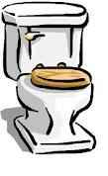

Magrill Elementary Restroom

Reward System
- Students “caught” following the behavioral expectations are rewarded with a ticket.
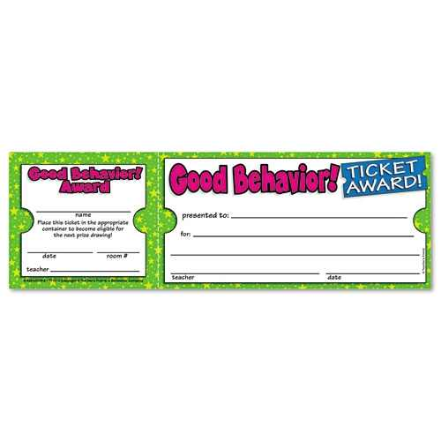
- Staff members receive 50 tickets a week with the goal of acknowledging appropriate restroom behavior that many times.
- When a student receives 10 tickets they earn 1 “Behavior Buck”.
- Behavior Bucks can be spent at the Magrill Store, located in the office, which is open Monday, Wednesday, and Friday during afternoon recess. Students may save bucks for different items.

